|  |  |
| --- | --- |
| TEAM ID | **PNT2022TMID53615** |
| PROJECT NAME | **SMART SOLUTION FOR RAILWAYS** |

PROJECT DEVELOPMENT DELIVERY OF SPRINT-1

SPRINT-1

STEPS TO BE DONE

1. Username and Password in node-red
2. Checking in Databases of IBM cloud
3. Login to Booking page

NODE_RED

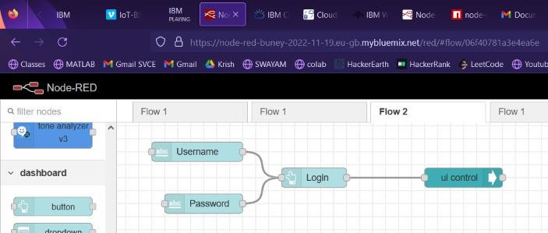

WEBPAGE

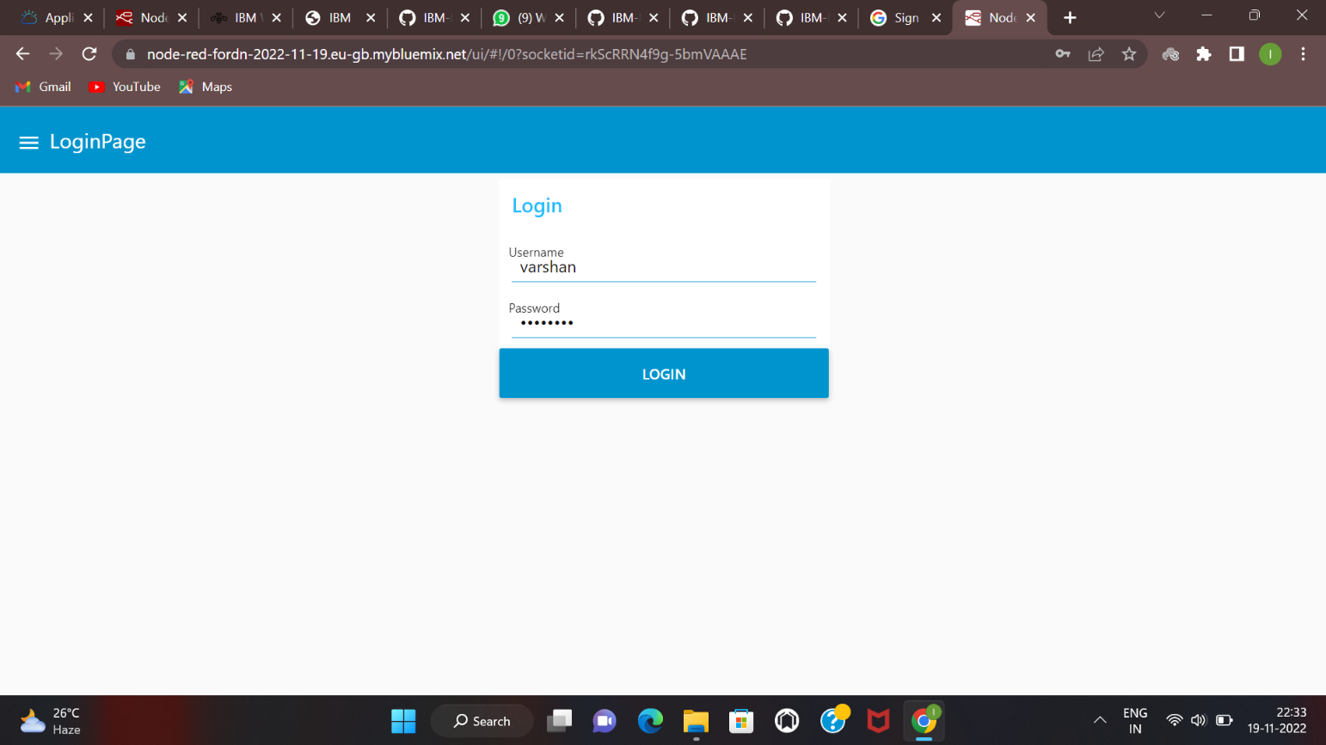

AFTER LOGGING NAVIGATES TO BOOKING PAGE

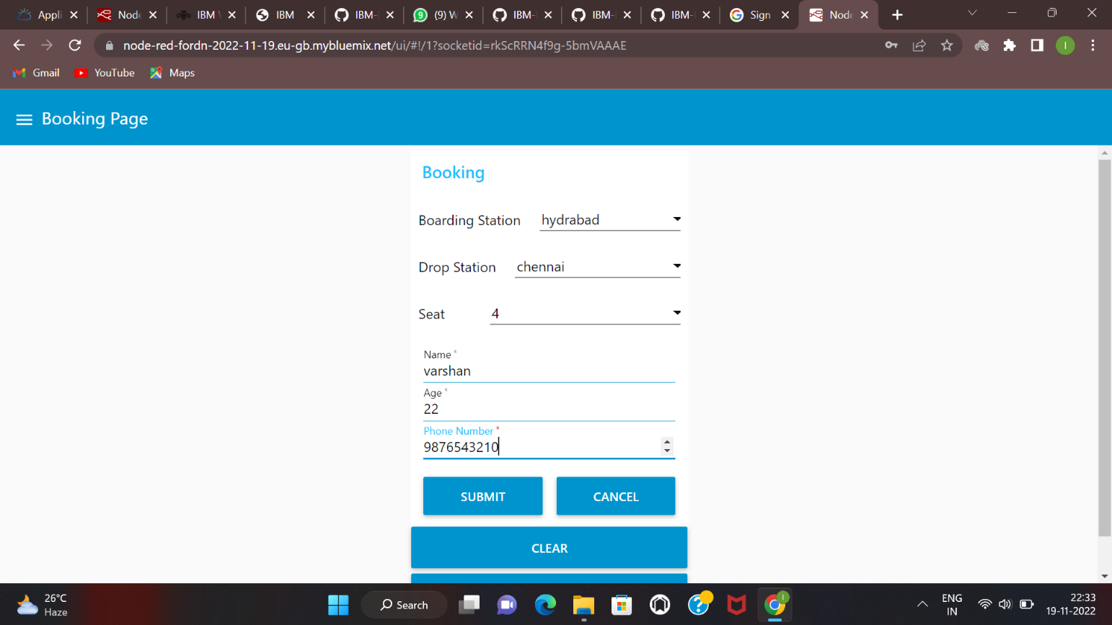

CHECKING IN CLOUD DATABASE

